SUBSCRIBE TO TEAM CALENDAR – Sync to iphone, calendars…
If you want to subscribe to a team calendar, you will need to go on the specific team(Team 1, Team 2…) and choose the option « Team Calendar » which will be on the right hand side.

Once this has been done, you will need to click the « subscribe button » on the very top of the calendar.

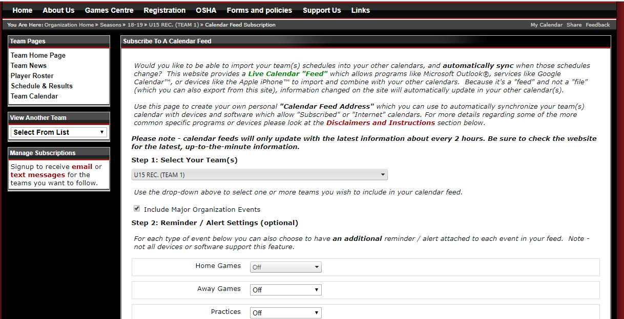
Afterwards, you will have a page which explains in details how to sync your team calendar to an iphone, google calendar, microsoft outlook…

